**ELEMENTS OF POWER SYSTEMS**

**EXPERIMENT 8**

**Simulink Model:**

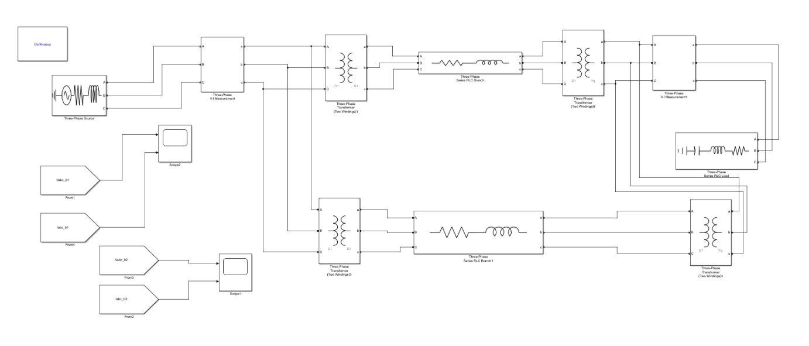

**Voltage and Current Graphs:**



